Er RAJAT KALIA
(B.TECH IIT-Delhi)
PH. 9815439805
Er MANISH KALIA
B.TECH (Delhi COLLEGE OF ENGINEERING)
PH. 09990074601,9878146388

9DE

INTRODUCTION

To find limit of a function is an interesting concept where it may be possible that value of the function does not exist at a point but we try to find the value in the neighborhood of the point. We will talk about this in more detail in the chapter. In the other part of the chapter we will discuss continuity of a function which is closely related to the concept of limits. There are some functions for which graph is continuous while there are others for which this is not the case…
Definition of Limit:
We sometime come across situations when the values of the function ‘f’ for values of ‘x’ near a point ‘c’ lie near a number ‘l’ which is not equal to f (c) or that value lie near no number at all.
Dumb Question:
1) How is it possible that function has different value near point c and at c?
Ans: Let us explain it with help of an example, Consider

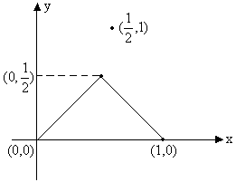
Fig (1)
In this function clearly the value of function near 1/2 lies near 1/2 but the value of
function at 1/2 is 1 which is not equal to 1/2.
So, there is need to introduce the notion of limit. A function f is said to tends to a limit l as x tends to ‘a’, if on approaching the point x=a from the values just greater than or just smaller than x=a, f(x) has tendency to move more closer to value l.
Mathematically we write this as
Which is equivalent to,
|f(x)-l| < ε ∀ x whenever 0 < |x-a| <δ, and ε and δ are sufficiently small positive numbers.

Right and Left hand limits:
Right hand limit:
If for every numbers ε>0 there exists corresponding number δ>0 such that for all x satisfying
a < x < a+δ
⇒ |f(x)-l)| <ε
Example: 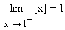
Left hand limit:
If for every number ε>0 there exists a corresponding δ>0 such that for all x satisfying a-δ< x < a ⇒ |f(x)-l|<ε
Example:
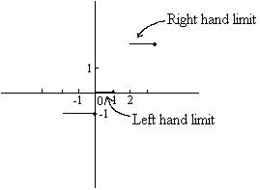
Fig (2)
Note that limit of a function exists at any point if and only if left hand limit is equal to right hand limit at that point.
Illustration 1:
Find the value of Where
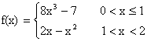
Solution:
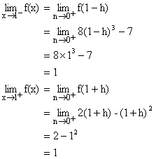
So, right hand limit and left hand limit are equal. Hence

Discovering infinity:
Infinity () is a symbol and not a number it is symbol for something which keeps increasing and passes all limits. Similarly - is symbol of a variable that continuously decrease and passes all limits.
Remember the following points:
1) We cannot plot on paper.
2) + = .
3) - is indeterminate.
4) × = .
5) 0 × is indeterminate.
6) 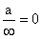If a is finite.
7) , ⁰, are all indeterminate.
Dumb Question:
1) It is often said ‘ + a’ where a is finite is . How is this possible?
Ans: Consider like an ocean. Now ‘a’ is like a bucket of water. If you add a bucket of water to ocean will the volume of ocean increase? It will remain ocean. So similarly remains on adding a finite number to it.
Illustration 2:
Find the value of ?
Solution:
= +
=
∴The value of = .

Theorem on Limits:
Let and . If l and m exist then,
1) .
2) .
3) 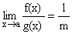Provided m ¹ 0.
4) Where k is constant.
5) If f(x) £ g(x) then l £ m.
6) 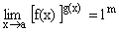.
7) If f(x) £ g(x) £ h(x) for all x.
and then (Squeeze play/ Sandwitch Theorem).
Illustration 3:
If [x] denotes the integral part of x, then find 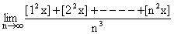.
Solution:
Let
Now we know
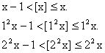
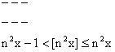
\ Adding them all gives us
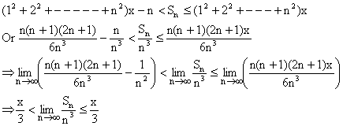
By using squeeze play theorem we get,
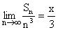.

Some important expansions (Power Series):
1) 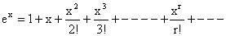.
2) 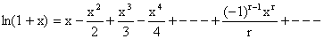 Here -1 < x £ 1.
3) 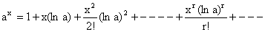.
4) 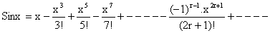.
5) 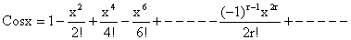.
6) 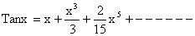.
7) 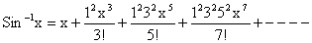.
8) 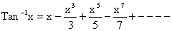
9) 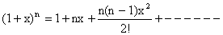(For rational or integral n).
Illustration 4:
Find the series expansion of Sin²x?
Solution:
Now we know that
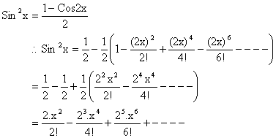
Note that many other series could be found in that way as we found the series for Sin²x.

Some Standard results on limits:
1)
2) 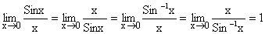
3) 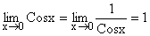
4) 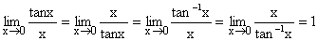
5) 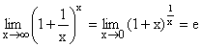
6) 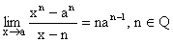
7) 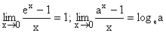
8) 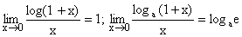
9) 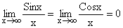
10)
Note: These limits could be derived using the series expansion or by L¹ Hospital’s rule which will discussed in a later section.
Illustration 5:
Find the value of 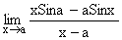?
Solution:
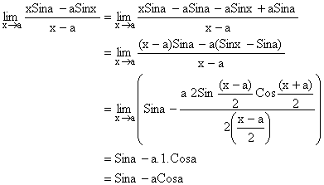

Evaluation of Limits:
1) Direct Substitution:
If we get a finite number by direct substitution of point we are done.
Illustration 6: Find 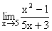?
Solution:
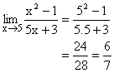

2) Algebraic Limits:
A) Factorization process of finding limit.
If direct substitution of x=a in a rational function takes useless form like 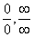then a factor of (x-a) can be cancelled from both numerator and denominator. Now again use direct substitution to see if limit can be evaluated.
Illustration 7:
Find 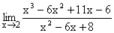?
Solution:
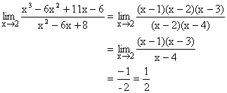
B) Using the result 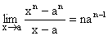
Illustration 8: Evaluate 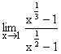?
Solution:
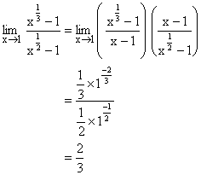
C) Using rationalization:
Some factor which creates form is cancelled by rationalization and limit is evaluated.
Illustration 9: Evaluate 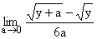?
Solution:
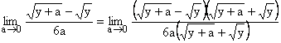
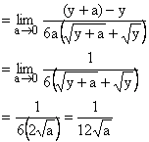
D) Limits where x®
We write down expression as a rational function and then divide each term by highest power of x obtained from numerator and denominator.
Illustration 10: Find the value of 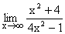?
Solution:
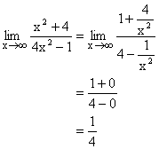
3) Trigonometric Limits:
The trigonometric limits are those which involve trigonometric ratios. The use of the result 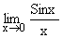is a integral part of evaluation of such limits.
Illustration 11: Evaluate 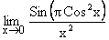?
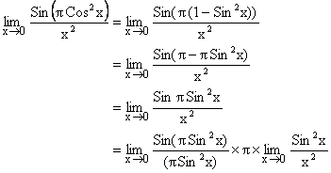
= 1´ p ´ 1
= p.
4) Exponential and Logarithmic Limits:
These are the limits which involve use of logarithmic and exponential functions. Some of the standard limits help us in solving these limits.
Illustration 12:
Find the following limits 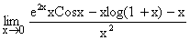
Solution:
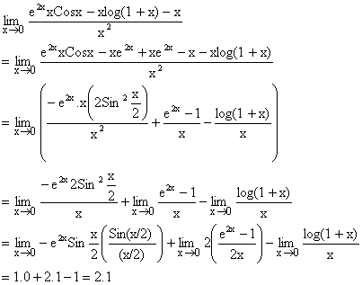

L’ Hospital’s Rule:
L’ Hospital’s Rule is applied only to the two forms 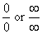.The rule states that if 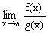is of the form then 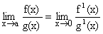 provided later limit exists. But if still it takes the form then we differentiate numerator and denominator again.
i.e. 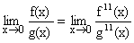and this process continues till we find that form is removed.
Illustration 13:
Evaluate
Solution:
Let A =
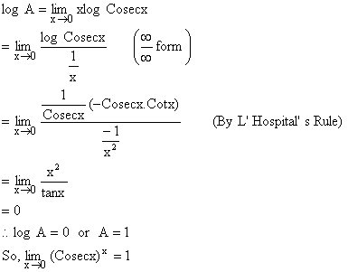

Continuity at point:
A function ‘f’ is said to be continuous at a point ‘a’ in domain of f, if following conditions are met.
1) f (a) exists.
2) exists finitely which essentially means that 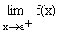and 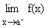both exist finitely and are equal.
3) . If anyone or more conditions are not met than function f is said to be discontinuous at point ‘a’. Geometrically graph of function exhibit a break at point x=a.
Illustration 14: Discuss the continuity of function y = f(x) as shown by graph below at the point x=1.
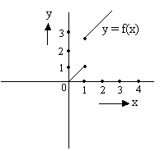
Fig (3)
Solution:
Now clearly the function exhibits a break at point x=1 and is thus discontinuous at x=1. But if we go by the rules mentioned in above article we observe that.
And
So does not exists and thus the function is discontinuous at x=1.
Continuity of function in open interval:
A function f is said to be continuous in (a, b) if f is continuous at each and every point belonging to interval (a, b).
Continuity of function in closed interval:
A function f is said to be continuous in closed interval [a, b] if
1) f is continuous in open interval (a, b) and
2) exists finitely and and
3) 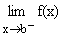exists finitely and 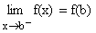.
Illustration 15:
Consider a function f(x) which is continuous in [1, 2] and given that f (1) = -1 and f (1) = 2, prove that there exists a point x such that f(x) =1.
Solution:
Let us arbitrarily choose some graph for f(x)
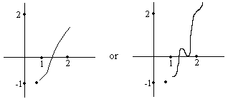
Fig (4)
For that matter function f(x) can take any shape. But since the function f is continuous between 1 and 2 it must be defined on all values lying between 1 and 2 and the function’s curve will go from y = -1 to y = 2 through some path. Whatever path be chosen y =1 will lie in between (Remember there cannot be a sudden jump because function is continuous)
Hence there exists a point x-where f(x) = 1.
Properties of continuous functions:
Let f(x) and g(x) are continuous functions at x=a then
1) K f(x) is continuous where K is constant
2) f(x) ± g(x) is continuous at x=a.
3) f(x) ´g(x) is continuous at x=a.
4) f(x)/g(x) is continuous at x=0 provided g (a) ¹ 0.
5) If m = f(x) is continuous at x=x₀ and f (m) is continuous at the point m₀ = f(x₀), then composite function f (f(x)) is continuous at point x₀.
6) If f(x) is continuous on [a, b] such that f (a) and f (b) are of opposite signs. Then there exists at least one solution of equation f(x) = 0 in the open interval (a, b).
7) Functions like sinx, cosx, tanx, cotx, secx, cosecx, logx, e^{x} etc are continuous in their domain.
Dumb Question:
1) How can function like tanx be continuous?
Ans: Please read the point mentioned above carefully. It is written that tanx is continuous in its domain. The points (2n+1)p/2 when tanx® do not lie in the domain of function f.
Illustration 16:
Let function 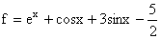Prove that there is a solution for equation f(x) =0 in the interval [0, 1].
Solution:
We observe that e^{x}, cosx, sinx, all are continuous functions in interval [0, 1]. So the function f is also continuous in [0, 1].
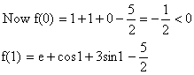
Since 0<1< (p/2) so cos1 and sin1 are positive quantities and e> .
So, f (1)>0.
Now f (0) and f (1) are of opposite signs. So f(x) =0 has a solution in interval [0, 1].
Classification of discontinuities:
1) Removable discontinuity:
Here at a point x=a of discontinuity, exists but f (a) is either undefined or if defined it does not tally with .
In this case the removal of discontinuity is achieved by modifying definition of function suitably so that f (a) tallies with which is found existing.
2) Irremovable discontinuity:
Here does not exist even though f (a) exists or additionally f (a) also does not exist.
Here, since does not exist, no modification of definition at x=a can succeed to make exist. Hence discontinuity remains irremovable.
Illustration 17:
Consider the function
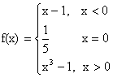
Discuss the continuity of function at x=0. If discontinuous suggest how to remove discontinuity.
Solution:
Let us plot the function f(x)
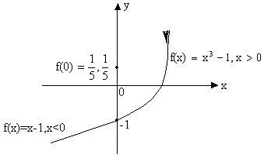
Fig (5)
Now
And 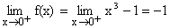
So, = = -1
But f (0) = .
\f (x) has removable discontinuity and f(x) can be made continuous by taking f (0) = -1.
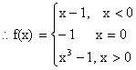

PROBLEMS (EASY TYPE)
1) Prove that 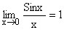
Solution:
And so 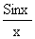assumes the indeterminate form 0/0 when x tends to 0.
We know for 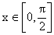
Sinx < x < Tanx
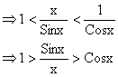
This is true for x>0, the same holds when x<0 in that Sin (-x)/ (-x) = and
Cos (-x) = Cosx.
Now since , it follows from sandwitch theorem,
.
2) Find the value of 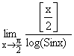.
Solution: As 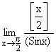
\ 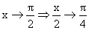
Where 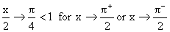
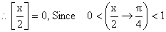
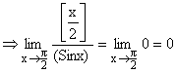
3) Evaluate 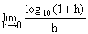.
Solution:
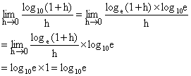
4) Evaluate 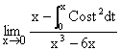.
Solution:
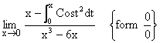
Applying L-Hospital’s Rule we get,
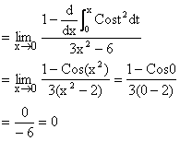
5) Find 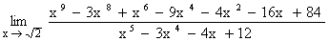.
Solution:
For both the numerator and denominator are 0.
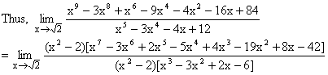
Given [x²-2 ¹ 0].
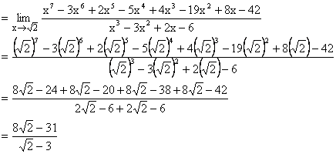
6) If 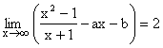then find the values for a and b.
Solution:
We have 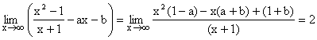
Since, limit of above expression is a finite non-zero number.
\ degree of numerator = degree of denominator
Þ 1-a = 0 Þ a = 1
\ Putting a = 1 in above limit we get
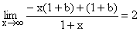
Þ - (1+b) = 2 Þ b = -3
Hence a = 1 and b = -3.
7) Let
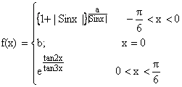
Determine a and b such that f(x) is continuous at x=0.
Solution:
Since f(x) is continuous at x=0.
Therefore R.H.L = L.H.L = f (0)
R.H.L at x = 0.
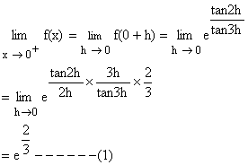
Again L.H.L at x = 0
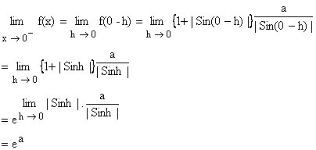
And f (0) = b ------ (2)
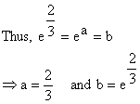

8) A function is defined as follows,
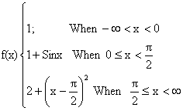
Discuss continuity of f.
Solution:
Continuity at x = 0
L.H.L at x = 0
R.H.L at x = 0
f (0) = 1+Sin0 = 1
= L.H.L = R.H.L = f (0) so f (x) is continuous at x = 0.
Continuity at 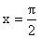
L.H.L at = 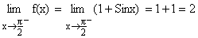
R.H.L at = 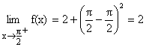
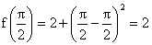
\ R.H.L = L.H.L = 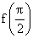
So, f(x) is continuous at .
Hence f(x) is continuous over the whole real number.
9) Discuss the continuity of the function:
g (x) = [x] + [-x] at integral values of x.
Solution:
Here x can assume two values a) Integers b) Non-Integers
a) If x is an integer
[x] = x and [-x] = -x Þ g(x) = x-x = 0.
b) If x is not an integer.
Let x = n+f Where n is an integer and f Î (0, 1).
Þ [x] = [n+f] = n.
Þ [-x] = [-n-f] = [(-n-1) + (1-f)] = (-n-1). (Because 0<f<1 Þ (1-f) <1)
Hence g(x) = [x] + [-x] = n + (-n-1) = -1.
So we get;
g(x) = 0; if x is an integer
= -1; if x is not an integer
Let us discuss the continuity of g(x) at a point x=a (Where a Î integer).
L.H.L = (as x®a⁻, x is not an integer)
R.H.L = (as x®a⁺, x is not an integer)
But g (a) = 0 because a is an integer.
Hence g(x) has a removable discontinuity at integral values of x
\ g (x) = [x] + [-x], xÏ integer.
= -1, x Î integer.
10) Let f(x) = x- |x-x²|, -1£ x £ 1. Discuss the continuity of f(x) in the closed interval
[-1, 1]. Draw the graph of f(x) in that interval.
Solution:
Here f(x) = x-|x (1-x)|
= x- |x| |x-1|, -1£ x £ 1.
Now using definition of modulus function we have
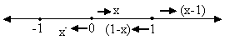
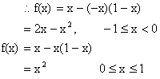
We know that polynomials are continuous every where, so only doubtful point is the turning point x=0 of definition.
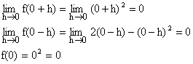
So f(x) is continuous at x=0.
Hence f(x) is continuous in [-1, 1].
Hence the graph of f(x) is continuous in [-1, 1] and
f (x) = 2x-x² in -1£ x < 0
x² in 0£ x £ 1.
\ The graph of f(x) is as follows;
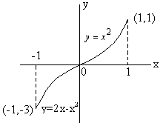
11) A function f(x) is defined by
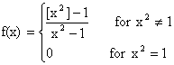
Discuss the continuity of f(x) at x=1.
Solution:
We have
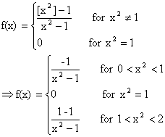
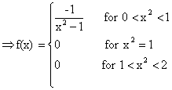
\ R.H.L at x² =1
Þ
Also L.H.L at x²=1
Þ 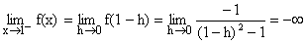
does not exist {as R.H.L ¹ L.H.L}
Hence f(x) is not continuous at x=1.

PROBLEMS (MEDIUM TYPE)
1) Without expansion or using L-Hospital’s Rule prove that 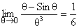.
Solution:
Let the limit be P then
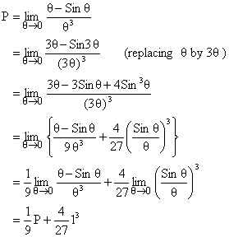
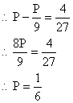
Dumb Question:
1) How can we replace q by 3q in the limit without changing it?
Ans: Since q ® 0, 3q will also tend to zero and thus there is no effect on the limit and thus it remains same.
2) Prove that
If x is rational.
If x is irrational.
Solution:
We know that |Cosq| £ 1 for all q.
If |Cos (n!p x) | = P <1,
limit =
As P^{2m} ® 0 When m® .
If |Cos (n!p x) | =1.
limit =
Now |Cos (n!p x) | =1
Þ n!px = kp, Where k is an integer.
\x = which is a rational number.
\ From (2) limit = 2 if x is rational.
Again |Cos (n!p x) |<1
Þ |Cos (n!p x) | ¹ 1 for all n Î N.
Þ n!px ¹ kp for all nÎN, k Î Z
Þ x ¹ for all n Î N, k Î Z.
Þ x is not rational i.e. x is irrational.
\From (1) limit = 1 if x is irrational.
3) Given 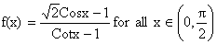except at 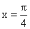. Define 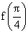so that f(x) may be continuous at .
Solution:
f (x) will be continuous at ,
If 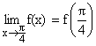
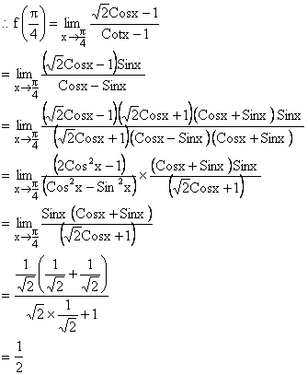
Dumb Question:
1) Why did we multiply by in both numerator and denominator?
Ans: The basic aim to do the multiplication was to cancel out Cos2x which was making the limit an indeterminate form.
4) Prove that (where [] denotes greatest integer function) is continuous in 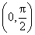.
Solution:
Here or , Where x = tanx ³ 0.
Then for a ÎN we discuss continuity of f(x) as L.H.L at x=a,
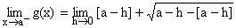
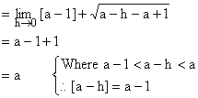
Now R.H.L at x=a.
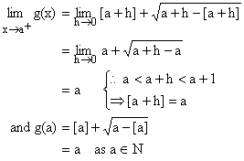
So, g(x) is continuous for all a ÎN, Now g(x) is clearly continuous in (a-1, a) for all
a ÎN.
Hence g(x) is continuous in [0,].
Now let f(x) = tanx which is continuous in .
So g {f(x)} is continuous in .
Hence is continuous in .

Find the point of discontinuity of 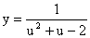where 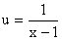.
Solution:
The function 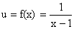is discontinuous at the point x=1 ----- (1)
The function 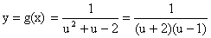is discontinuous at u=-2 and u=1.
When u = -2, 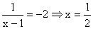
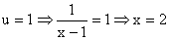
Hence composite function y = g(x) is discontinuous at three points 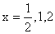.
6) If 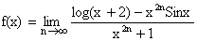examine the continuity of f(x) at x=1.
Solution:
To examine the continuity at x=1, we are required to derive the definition of f(x) in the intervals x<1, x>1 and at x=1, i.e. on and around x=1.
Now if 0<x<1
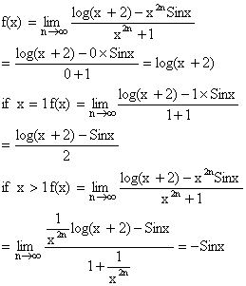
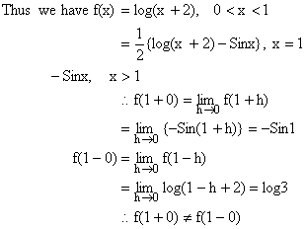
So f(x) is not continuous at x=1.
Dumb Question:
1) How does 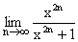varies with the value of x?
Ans: Now suppose x<1
So,
∴ =0
If x =1 then 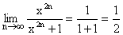
If x>1 then
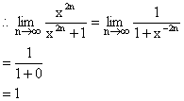
7) Show 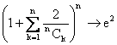as n→ (for n ≥ 6)
Solution:
Let 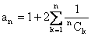while for n ≥ 6.
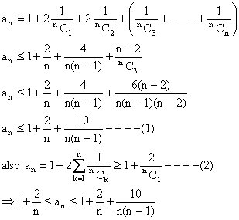
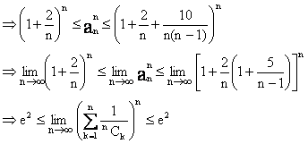
∴ By squeeze principle for limits,
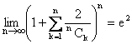.

KEY WORDS
➢ Limit
➢ Extending / Approaching
➢ Right Hand Limit
➢ Left Hand Limit
➢ Infinity
➢ Sandwitch Theorem / Squeeze play Theorem.
➢ Power Series
➢ L-Hospital’s Rule
➢ Continuity
➢ Removable discontinuity
➢ Irremovable discontinuity

DIFFERENTIABILITY
INTRODUCTION
For many years the path in which planets were revolving round the sun was not known. After many years of observation Kepler conducted that planets move around the sun in elliptical orbits. But he could not give logical reasoning for his claim. But once Newton and Leibniz gave the fundamental theorem of calculus, the reasoning for this and many more things became quiet clear. Since then differential calculus has proved itself to be indispensable in development of mathematics and physics sciences.
In this section we will talk about some techniques of differentiation and their application to various question

So let us start with DIFFERENTIATION.

Definition of Derivative:
The derivative f¹(x) of a function y = f(x) at a given point x is defined as
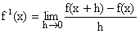
Where f¹(x) is called derivative of f(x) with respect to x.

Derivation of f(x) from first principle (i.e. Definition on ab-init):
Let y = f(x) for an increment dx in x, let dy be the corresponding increment in y.
y + dy = f (x+dx).
dy = f (x+dx)-f(x)
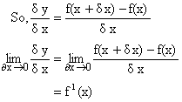
f¹(x) if exists is called derivative of f(x) w.r.t x.
Note: 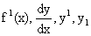all represents the same thing.
Illustration 1:
Find the derivative of w.r.t x using the first principle?
Solution:
Let y =
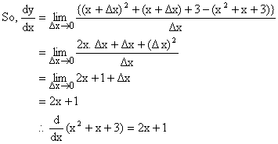

Right and Left Derivative of a function:
The Right hand derivative of a function at point ‘a’ denoted by is defined as
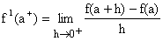
Similarly left hand derivative of function at ‘a’ denoted by is defined as
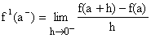
Differentiability of a function at a point:
A function f(x) is said to be differentiable at a point ‘a’ if
1) Both and are exist and are finite.
2) = .
Illustration 2:
Prove that function |x-1| is not differentiable at x=1.
Solution:
Let us find the right hand derivative and left hand derivative of this function.
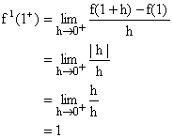
Similarly
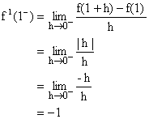
Now since , so the function is not differentiable at x = 1.

Geometrical Interpretation of a Derivative:
Let us take two point P[c, f(c)] and Q[c+h, f(c+h)] on curve y = f(x).
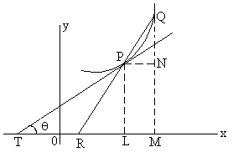
Fig (1)
We join PQ so that it is a secant to curve.
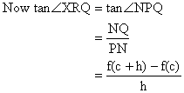
Now as h approaches O the point Q moving along curve approaches point P, the chord PQ approaches tangent line TP and ÐXRQ approaches ÐXTP denoted by Q.
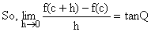
Hence f¹(c) is slope of tangent to the curve y = f(x) at point (c, f(c)).
Illustration 3:
Show that tangent to hyperbola 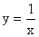at (1, 1) makes an angle with x-axis.
Solution:
Let the angle the tangent makes beq.
So, we know that
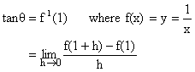

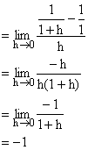
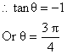

Derivability of f(x) on an interval
f(x) is said to be derivable on the closed interval [a, b] if
1) For the points a and b, , and finitely exist.
2) For any point c such that a<c<b, and finitely exist and equal.
3) f(x) is said to be derivable on open interval (a, b) for any point c such that a<c<b,
And finitely exists and are equal.
Illustration 4:
Consider the function;
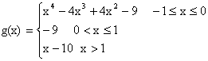
Discuss differentiability of g(x) in [-1,¥].
Solution:
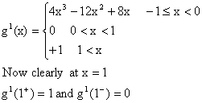
So, g(x) is not differentiable at x=1.

Relationship between continuity and differentiability:
If a function f is differentiable at a point ‘a’ then it is continuous at that point but if a function f is continuous at a point ‘a’ then it need not necessarily be differentiable at that point.
For Example:
y = |x| + 1 is continuous at x=0 but not differentiable.
Dumb Question:
1) How do we know that |x|+1 is not differentiable at x=0?
Ans:
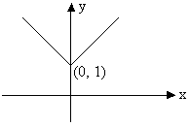
Fig (2)
The graph of function y = |x| + 1 looks like the figure mode above.
Now remember that derivative of a function represents the slope of graph at that point. So if there is no tangent line at certain point, function is not differentiable at that point or in other words function is not differentiable at corner point of a curve. And hence not differentiable at x=0.
Tips to check differentiability and continuity:
1) It is advantageous to check differentiability first because every differentiable function is continuous.
2) On the other hand every discontinuous function is non-differentiable.
3) If right hand derivative is not equal to left hand derivative but both exist finitely at x=a then function is not differentiable but continuous at x=a.
4) Continuity of a function does not imply its differentiability.
5) Also, non-differentiability of a function does not mean that it is discontinuous at point a.

Illustration 5:
Function f is defined by;
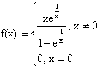
Show that f is continuous but not derivable at x=0.
Solution:
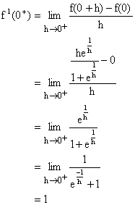
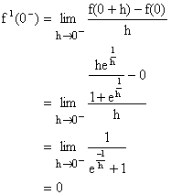
So, f(x) is not derivable at x=0.
But since both and exist finitely the function is continuous at x=0.

Dumb Question:
1) Why 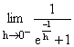 is 0 and 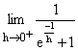is 1?
Ans:
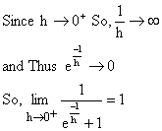
But when 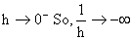 and thus
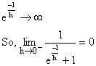
General Theorem on Differentiation:
1) (Constant) = 0 why?
Proof: Let f(x) = k.
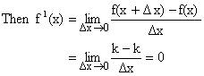
Therefore (Constant) = 0.
2) [c f(x)] = c (f(x)); where c is a constant why?
Let g(x) = c.f(x)
Where c is constant and f(x), xÎR be a differential function of x. We then have,
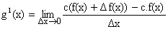

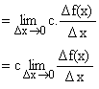
Thus [c f(x)] = c (f(x)).

3) 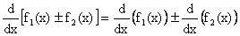 Why?
Proof:
Let y = f₁(x) + f₂(x), Where f₁(x) and f₂(x) are differentiable functions of x.
Then
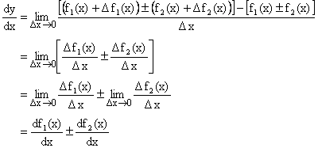
Thus .
4) 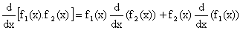Why?
Proof:
Let y = f₁(x).f₂(x) where both f₁(x) and f₂(x) are differentiable function of x.
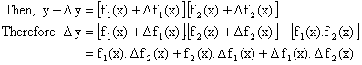
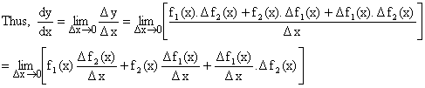

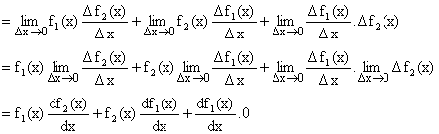
5) 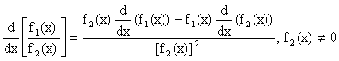 Why?
Proof:
Let 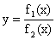, where f₁(x) and f₂(x) are differentiable functions at all points in its domain and f₂(x) ¹ 0.
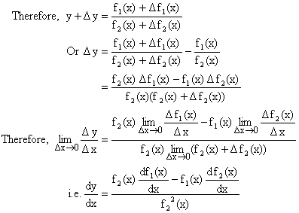
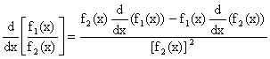

6) 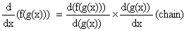Why?

Proof:
Let y = f (t), t = g(x)
Then y = f (g(x)) is a function of x.
Dy = f (t+Dt) - f (t)
And Dt = g (x+Dx) - g(x)
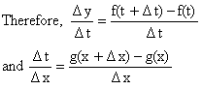
Assuming that for sufficient small values of Dx, Dt ¹ 0 this will necessarily be the case if 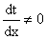then since g is differentiable it is continuous and hence when Dx®0, x+Dx®x any g(x+Dx) ® g(x).
Therefore t+Dt®t and Dt®0, since Dt ¹ 0 and Dx®0 we may write,
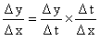.
Clearly f and g are both continuous functions because they are differentiable thus Dt®0 when Dx®0 and Dy®0 when Dt®0.
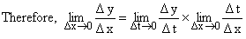
Hence 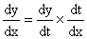

Standard Formulae of Differentiation:
1) 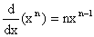
Proof:
Let
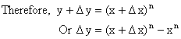

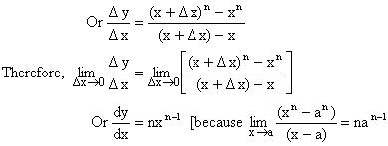
Thus
2) 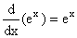
Proof:
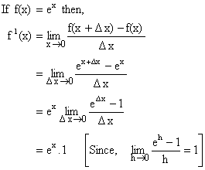
Thus
3) 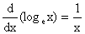
Proof:
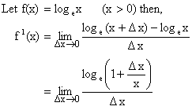

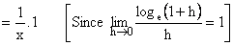
So,
4) 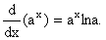
Proof:
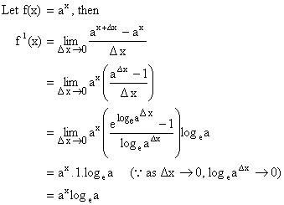

5) 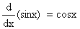
Proof:
Let f(x) = sinx then,
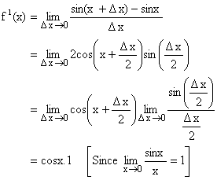
Hence,

6) 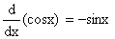
7) 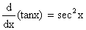
8) 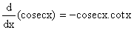
9) 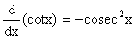
10) 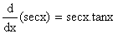 Why?
Proof:
Let f(x) = secx
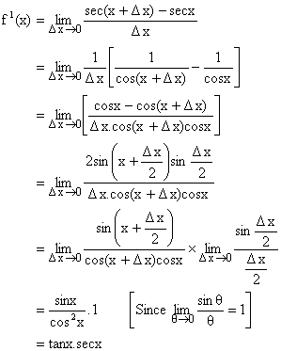
Hence,
11) 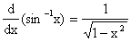
Proof:
Let then x = siny.
Differentiating w.r.t x we get,
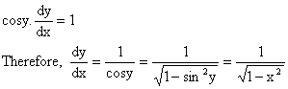
Hence,
12) 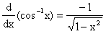
13) 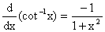
14) 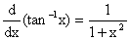
15) 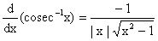
16) 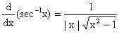Why?
Proof:
Let y = sec⁻¹x then secy = x.
Differentiating w.r.t x we have,
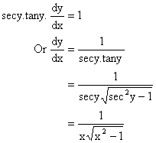
Hence,

Dumb Question:
Why and not 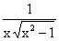?
Ans:
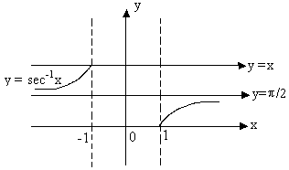
Fig (4)
Note that y = sec⁻¹x is an increasing function in its domain.
So,
Illustration 6:
Differentiate 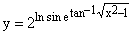
Solution:
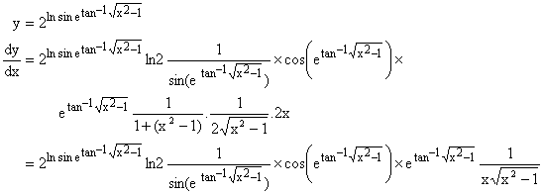
Different Methods of Differentiation:
1) Differentiation of a function defined parametrically:
Let x, y be function of parameter t, i.e.
x = f (t), y = f (t) then,

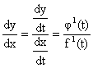
Illustration:
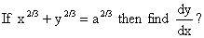
Solution:
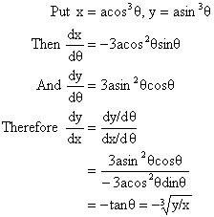
2) Logarithmic Differentiation:
The process of taking logarithm on both sides and then differentiating is called logarithmic differentiation.
Illustration 8:
Differentiate w.r.t x.
Solution:
Let y = .
Taking logarithm on both sides, then we have
logy = sinx.logx
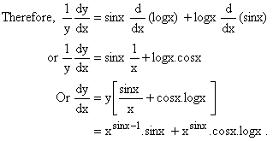
3) Differentiation of Implicit function:
If the relation between x and y is given by equation containing both and this equation is not immediately solvable for y, then y is called implicit function of x.
Illustration 9:
If Then prove that 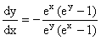
Solution:
Given that differentiating on both sides w.r.t x we have,
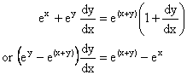
Hence,

4) Differentiation of a function w.r.t other functions:
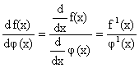
Illustration:
1) Differentiate 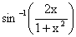with respect to tan⁻¹x.
Solution:
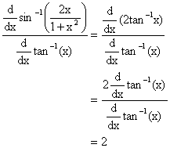

2) Differentiate ln tanx with respect to
Solution:
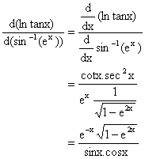
5) Higher Order derivatives:
Let y = f(x) be differentiable function such that z = f¹(x) is also differentiable. Then second derivative of y = f(x) is denoted by 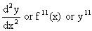and 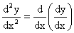.
In general 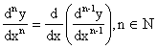
Illustration 11:
For the curve find the rate of change of slope at (4, 27).
Solution:
We know that slope of a curve is given by . Now let g(x) denote slope of curve.
So, 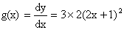
Now rate of change of slope =
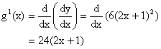
So rate of change of slope at (4, 27)
= 24(2´4+1)
= 216.

DIFFERENTIATION (EASY TYPE)
1) Differentiate 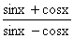with respect to x.
Solution:
Let y = then,
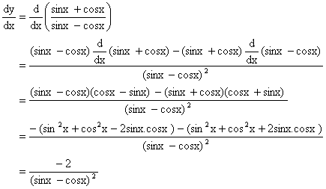
2) Let f be twice differentiable such that f¹¹(x) = -f(x) and f¹(x) = g(x). Where h (5) = 11, find h (10).
Solution:
Given on differentiating both sides w.r.t x we get
Now
From (1) and (2) we get,
Therefore h¹(x) = 0.
So, h(x) must be constant [as d/dx constant = 0]
But h (5) = 11 so h (x) = 11
Hence, h (10) = 11.

3) Find the sum of series 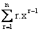using calculus.
Solution:
Let which is a geometric progression.
Therefore = 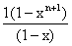
On differentiating both sides, we get,
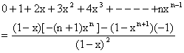
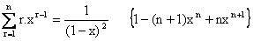
4) If and then find .
Solution:
Differentiating w.r.t x, we get,
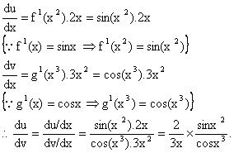

5) If 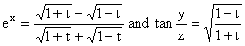then find at 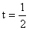.
Solution:
Putting t = cosq.
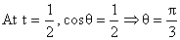
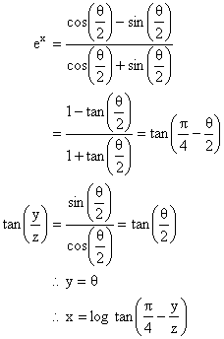
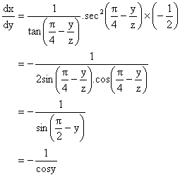
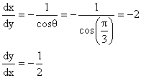

6) If a polynomial of degree 3 then find 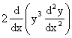in terms of P(x) and its derivative.
Solution:
We have
And
Also
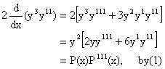
7) If 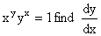
Solution:
Taking log on both sides
ylogx + xlogy = log1.
Differentiating on both sides we get,
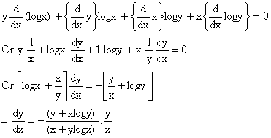
8) If x = a (t+sint) and y = a (1-cost), Then find 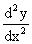
Solution:
Here x = a (t+sint) and y = a (1-cost).
Differentiating both sides w.r.t t we get,
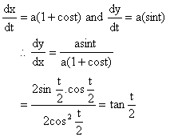
Again differentiating both sides we get,
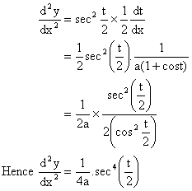

9) Find 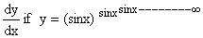
Solution:
We have
Therefore by taking log on both sides we get,
logy = y log sinx.
Differentiating both sides w.r.t x we get,
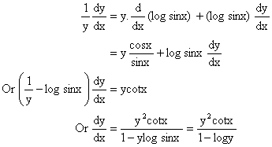

10) Is f(x) differentiable at x=0 if f(x) is defined as follow
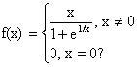
Solution:
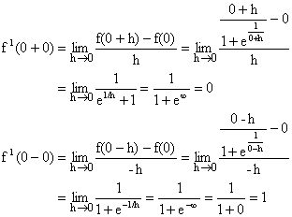
Here f(x) is not differentiable at x=0.
11) Determine the values of x for which the following function fails to be continuous or differentiable.
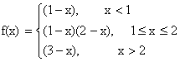
Justify your Answer.
Solution:
By given definition it is clear that the function f is continuous and differentiable at all points except possibility at x=1 and x=2.
Continuity at x=1,
L.H.L =
R.H.L =
Also f (1) = 0, Hence f(x) is continuous at x=1.
Now differentiability at x=1.
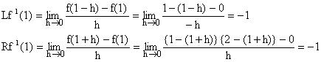
Since so we get f(x) is differentiable at x=1.
Continuity at x=2.
Since R.H.L ¹ L.H.L
Therefore f(x) is not continuous at x=2. As such f(x) can not be differentiable at x=2. Hence f(x) is continuous and differentiable at all points except at x=2.

12) If
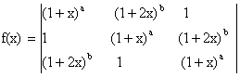 Then find a) Constant term b) Coefficient of x.
Solution:
Here 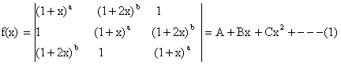
Putting x =0 we get
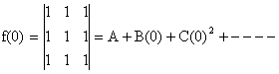
Þ A=0
Again Differentiating (1) w.r.t x we get,

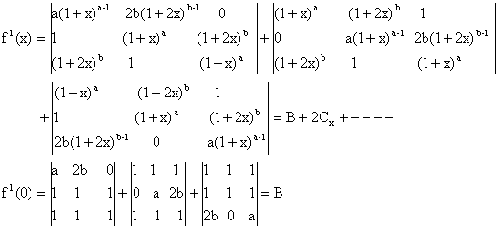
Therefore Coefficient of constant term = Coefficient of x = 0.

(MEDIUM TYPE)
1) Let f(x) be a real function not identically zero such that , nÎN and x, y are any real numbers and f¹(0) ³ 0. Find the values of f (5) and f¹(10).
Solution:
Here ------ (1)
Putting x=0, y=0 we get f (0) = f (0) + {f (0)}^{2n+1}.
\ f (0) = 0.
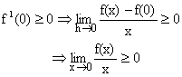
\ If x ³ 0, f(x) ³ 0 -------- (2)
Putting x = 0, y = 1 in (1)
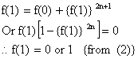
Putting y=1 in (1) for all real x,
f (x+1) = f(x) + {f (1)}^{2n+1}------ (3)
\f (1) = 0 Þ f(x+1) = f(x)
Þ f (1) = f (2) = f (3) = ------ = 0
i.e. f(x) is identically zero.
\ f (1) ¹ 0 Hence f (1) =1.
So from (3) f(x+1) = f (x) +1 ---- (4)
\ f (5) = f (4) +1 = {f (3) + 1}+ 1
= {f (2) +1} +2
= {f (1) +1} +3
=f (1) +4
=1+4
=5
Also (4)Þ f(x) is a function whose value increases by 1.When variable x is increased by 1.
\f (x) = x \f¹(x) = 1
\ f¹(10) =1.

Dumb Question:
1) Why does the equation has the solution as f (1) = 0, 1? Some complex solution could also be possible.
Ans: It is mentioned in the question that function f is real valued function, so the value of f (1) has to be real and cannot be complex.
2) If f be a function such that f (xy) = f (x). f (y), " yÎR and f (1+x) = 1+x (1+ g(x)). Where , find the value of 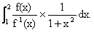
Solution:
We know,
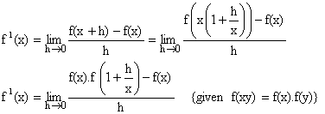

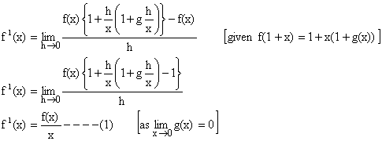
To find
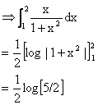

) Let f be differentiable function such that, 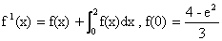 find f(x)?
Solution:
Given that
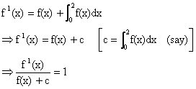
Integrating above expression both sides,
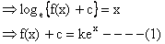
Where k is a constant of integration
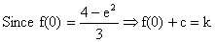

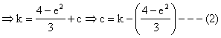
From (1) and (2) we get,
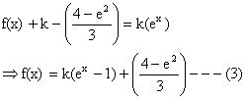
Now to find constant of integration k.
Integrating both sides from 0 to 2 we get,
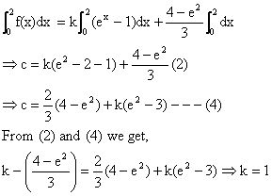
Putting k=1 in (3) we get,
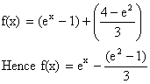
4) Let f(x+y) = f(x) –f (y) + 2xy -1 for all x, y ÎR, if f(x) is differentiable and prove that f(x)>0 for all xÎR.
Solution:
Putting x = 0 = y in given functional equation, we get f (0) = -1.
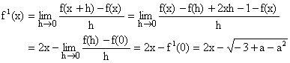

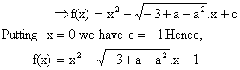
The discriminant
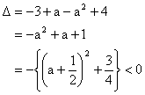
Hence, f(x) > 0 for all xÎR.
Dumb Question:
1) How does 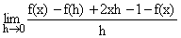transform to 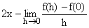?
Ans:
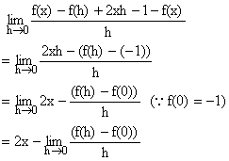
5) If then express y as an explicit function x and prove that 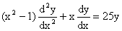.
Solution:
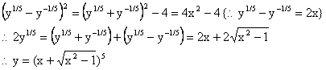
Differentiating w.r.t x,
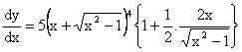
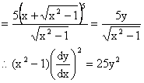
Differentiating w.r.t x,
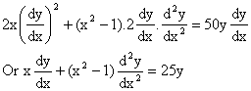
Therefore 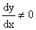for then y is constant.
Dumb Question:
1) Why is ?
Ans:
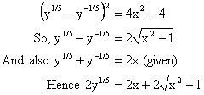
6) The function y = f(x) is defined as follows, x = 2t-|t|, y = t² + t |t|, tÎR. Then discuss the continuity and differentiability of the function at x=0 also draw the graph of the function in the interval [-1, 1].
Solution:
When t < 0, x = 2t -(-t) = 3t < 0.
y = t² + t (-t) = 0.
\y = 0 when x<0.
When t ³ 0, x = 2t-t = t ³ 0.
y = t²+t (t) = 2t² = 2x²
\ y = 2x² when x ³ 0.
Thus the function is as follows.
f (x) = 0, x<0
=2x², x ³ 0
Now,
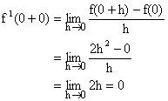
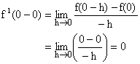
\f (x) is differentiable (finitely) at x=0.
\ f (x) is also continuous at x = 0.
Being a polynomial function f(x) is continuous at other points of the interval [-1, 1].
Now in the interval [-1, 1] we have y = 0 in [-1, 0], y = 2x² in [0, 1]
So the graph is as below.
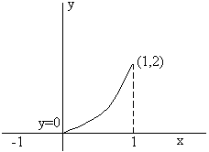
Fig (5)

(HARD TYPE)
1) 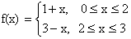
Determine f {f(x)} and hence find the points of discontinuity and non-differentiability. Also draw the graph of f {f(x)} in [0, 3].
Solution:
Clearly f {f(x)} = 1+ f(x), 0 £ f(x) £ 2
3 - f(x), 2 < f(x) £ 3
When 0 £ f(x) £ 2
0 £ 1+x £ 2, if 0 £ x £ 2 {using first piece of definition}
Þ -1 £ x £ 1 if 0 £ x £ 2
Þ 0 £ x £ 1 (taking the interval of common points)
\ 0 £ f(x) £ 2 when 0 £ x £ 1 and f(x) = 1+x --------- (1)
When 0 £ f(x) £ 2
0 £ 3-x £ 2 If 2 < x £ 3 (using the second piece of definition)
Þ -3 £ -x £ -1 If 2 < x < £ 3
Þ 1 £ x £ 3 If 2 < x £ 3
Þ 2 < x £ 3 (taking interval of common points)
\0 £ f(x) £ 2 when 2 < x £ 3 and f(x) = 3-x ----- (2)
When 2 < f(x) £ 3
2<1+x £ 3 If 0 £ x £ 2 (using the first piece of definition)
Þ 1< x £ 2 If 0 £ x £ 2
Þ 1< x £ 2
\2< f(x) £ 3 when 1< x £ 2 and f(x) = 1+x ------- (3)
When 2< f(x) £ 3
2<3-x £ 3 If 2 < x £ 3 (using second piece of definition)
Þ -1 < -x £ 0 If 2 < x £ 3
Þ 0 £ x <1 If 2 < x £ 3
Þ xÎf.

Thus we get
f {f(x)} = 1+1+x = 2+x, 0 £ x £ 1 {from (1)}
= 1+3-x = 4-x, 2 < x £ 3 {from (2)}
= 3-(1+x) = 2-x, 1 < x £ 2 {from (3)}
Hence the function is
f {f(x)} = 2+x, 0 £ x£ 1
2-x, 1< x £ 2
4-x, 2 < x £ 3

As the polynomial functions are continuous and differentiable every where f {f(x)} is continuous and differentiable in [0, 3] except perhaps at the turning points of definition, namely, x = 1, 2 denote f {f(x)} by g(x).
Now g (1+0) = 2-1=1
g (1-0) = 2+1 = 3
So g(x) is not continuous at x=1.
g (2+0) = 4-2 =2
g (2-0) = 2-2 = 0
So, g(x) is not continuous at x=2.
Hence g(x) is also not differentiable at x = 1, 2.
\The points of discontinuity and non-differentiability are x=1, 2.
Now we have to draw the graph for y = f {f(x)} where
y = 2+x in [0, 1],
y = 2-x in [1, 2]
y = 4-x in [2, 3]
The graph is discontinuous at x = 1, 2.
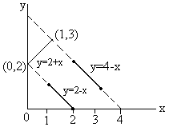
Fig (6)
Dumb Question:
1) In the above solution, there is a condition 0 £1+x £2 if 0 £ x £ 2 from that it is inferred that 0 £ x£ 1 How?
Ans:
0 £1+x £2 if 0 £ x £ 2
Þ -1 £ x £ 1 if 0 £ x £ 2
Now clearly both the conditions need to be satisfied simultaneously. So the intersection of these two conditions will give the desired results.
i.e. 0 £ x £ 1
2) If then find 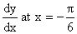from the first principle.
Solution:
Clearly the definition of the function f(x) is 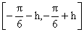where h is a very small positive quantity, remains the same, so 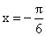 is not a turning point of definition.
Now,
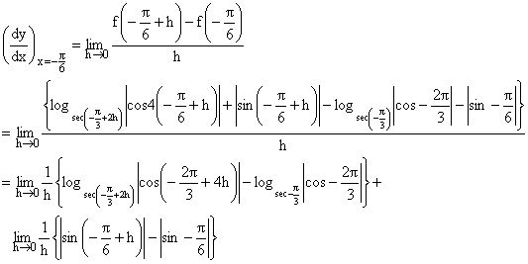

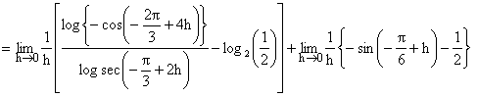
(Using definition of mod)
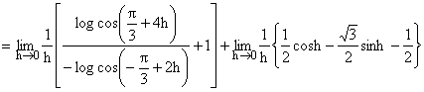
Now 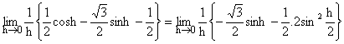
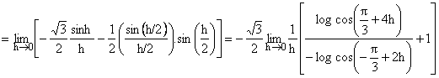
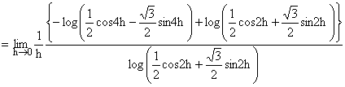
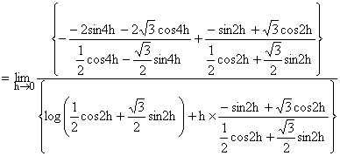
(Using L-Hospital Rule)
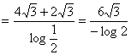

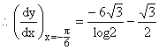

3) Let a+b =1, 2a²+2b² =1 and f(x) be a continuous function such that f (2+x) +f(x) = 2 for all xÎ(0, 2) and p = 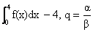then find the least positive integral values of ‘a’ for which the equation ax²-bx+c = 0 has both roots lies between p and q;
Where a, b, c ÎN.
Solution:
Given a+b =1 --------- (1)
2a²+2b² =1 -------- (2)
Solving equation (1) and (2) we get,
a = b = .
Þ 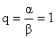----------- (3)
Given f(x+2) +f(x) = 2 for all x Î[0, 2] -------- (4)
Now p = 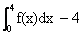
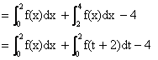
(let x = t+2 for second integration}
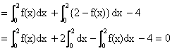
Then p =0, q=1
Let the roots of equation ax²-bx+c = 0 be a and b
\f (x) = ax²-bx+c= a(x-a) (x-b) -------- (5)
Since equation f(x) = 0 has both roots between 0 and 1.
\f (0).f (1) > 0 ------- (6)
But f (0).f (1) = c (a-b+c) = an integer ------- (7)
Therefore least value of f (0). f (1) = 1 -------- (8)
Now from equation (5)
f (0).f (1) = a a b a (1- a) (1-b)
= a²ab (1- a) (1- b) --------- (9)
As we know
a (1- a) has greatest values 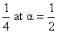and b (1- b) has greatest value 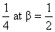
But b ¹ a
Thus from equation (8) greatest value of
f (0). f (1) < ------ (10)
From (8) and (10)
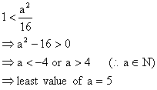
{As a Î Natural number}
Dumb Question:
1) Why c (a-b+c) is an integer?
Ans: It is given in the question that a, b, c ÎN
So, cÎN and a-b+cÎI
So, c (a-b+c) ÎI
Hence c (a-b+c) is an integer.

KEYWORDS
✓ Derivative
✓ First Principle
✓
✓ Right Hand Derivative
✓ Left Hand Derivative
✓ Parametric
✓ Logarithmic Differentiation
✓ Implicit function
✓ Chain Rule

